Getting Started With Git

We can imagine that web design is like a building and Git is one of the many important pillars that web design is built on.  
Our primary objectives right now are to:

* Understand what Git is
* Learn how to use the basic Git commands
* Discover how to configure Git
* Understand what Github is and how to work with remote repositories

# What Is a VCS?

A version control system is a software tool that helps developer teams track and manage source code changes over time.

As you edit and add to your code, you tell the version control system to take a snapshot of your files or save a checkpoint of your progress.  
The version control system saves that snapshot permanently so you can recall it later on if you need it.

Without a VCS, you’re tempted to keep multiple copies of code on your computer. This is dangerous because it’s easy for a file to get corrupted or deleted meaning you’re susceptible to losing months or even years worth of work.

Version control systems solve that problem by presenting you with all versions of your code with a clear history of the changes made. This allows you to go back to older versions of the code and try a different approach.

# What Is Git?

Git is a free and open source VCS designed to handle everything from small to very large projects with speed and efficiency.

In plain English, Git is a tool that allows developers to track versions of their code over time. It does this by creating "snapshots" of the current state of the code base whenever you tell it to.

Git is essential when collaborating with other developers to ensure that there are no code conflicts between them and that previous "snapshots" of the code can be revisited if necessary.

For example, if you are coding and you accidentally break or crash the app, you’ve just lost all your progress and you’re forced to start from scratch. However, it’s easier and safer if you're using Git and you can simply roll back to a previous version of the code.

Installing Git

Git isn’t usually set up by default on your computer, so you need to install and configure it before you can start using it to manage your code.  
It’s important to keep Git up to date, just like all the other software on your machine. Updates protect you from security vulnerabilities, fix bugs, and give you access to new features.

The recommended method of installing and maintaining Git is provided for three major platforms below:

**Windows**  
Download and install Git for [Windows](https://git-scm.com/download/win). Once installed, you’ll be able to use Git from the command prompt or PowerShell. We recommend that you stick with the defaults selected during the installation unless you have a good reason to change them.  
**Linux**  
On the terminal, just run sudo apt install git-all.  
**Mac**  
The best thing to do is to install [Homebrew](https://brew.sh/) and then from the terminal run the command brew install git.

Start Using Git

Once we have Git installed we need to "initialize" a repository before we can start using it.  
It’s very easy to do, just follow my lead:

1. Access the wanted folder using the terminal (prompt cmd).
2. To initialize a repository, we only have to run:

git init

Output

***P.S*** : This command just created a hidden folder called .git, where all the magic happens.

# Adding and Committing Files

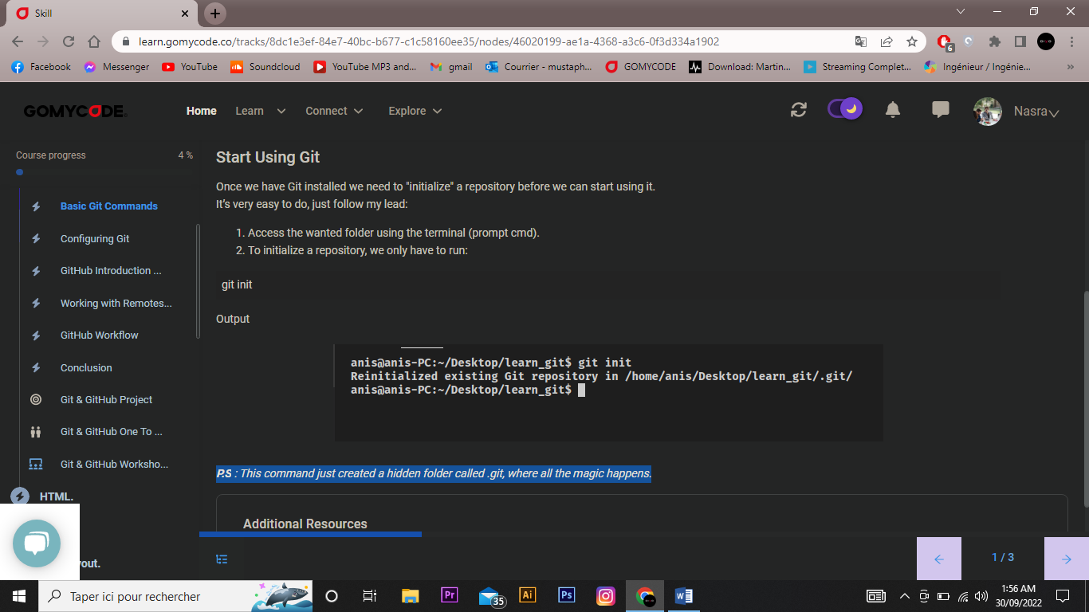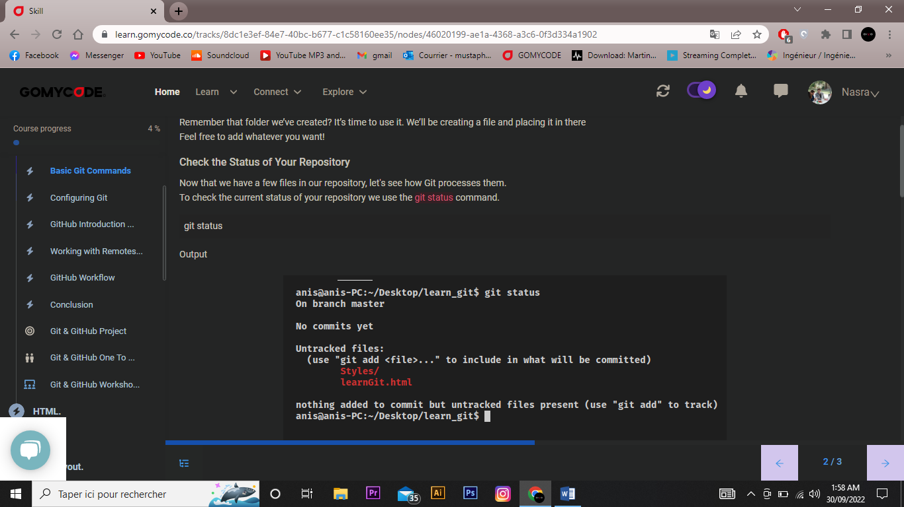

## **Adding Files for Git to Track**

At this point, we do not have any files for Git to track.  
We need to add files specifically to Git in order to tell Git to track them. We add files using the “add” command.  
After running git add . Git will add all the repository files to an intermediate area called the **staging area**. We can also add what we want simply by running git add myFileName

git add .

